S3 – GROUP BY - AVG -SUM

# What you will know:

GROUP BY – AVG - SUM

# Instructions:

* Open [this online SQL editor](https://www.w3schools.com/sql/trysql.asp?filename=trysql_op_in)
* Look at the content of the Product table, using a SQL command or by clicking on the link on the right side:

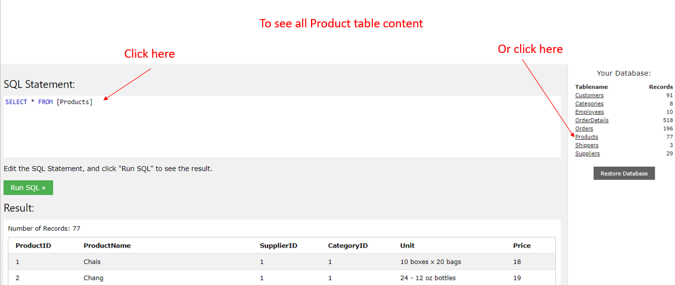

Each product of **Products** table has a **category ID** (*this ID refers to an element in the* ***Categories*** *table*)

## Q1

Write a SQL query to display the **number of products per category**.

Expected columns:

CategoryID Number of items

**Your query:**

**SELECT CategoryID, COUNT(ProductID) AS “Number of items”**

**FROM Products**

**GROUP BY CategoryID;**

## Q2

Write a SQL query to display the **average price** of items per category ID.

Expected columns:

CategoryID Average items price

**Your query:**

**SELECT CategoryID, AVG(ProductID) AS “Average items price”**

**FROM Products**

**GROUP BY CategoryID;**

## Q3

Write a SQL query to display the **total of the price** of all items per category ID.

Expected columns:

Category ID Total items price

**Your query:**

**SELECT CategoryID, SUM(ProductID) AS “Total items price”**

**FROM Products GROUP BY CategoryID;**

**SELECT CategoryID, SUM(Price) AS “Total items price”**

**FROM Products GROUP BY CategoryID;**

**Exercise 2: World Table**

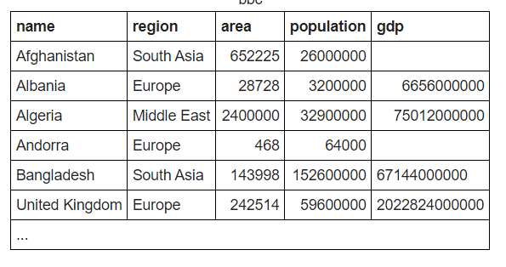

**Q1:** write a statement to sum of population of all countries.

**Your query: SELECT SUM(population) FROM world;**

**Q2** : write a statement to sum of population of all countries in «South Asia»

**Your query: SELECT SUM(POPULATION) FROM WORLD WHERE REGION = ‘**South Asia**’ ;**

**Q3:** write a statement to count GDP is null

**Your query: SELECT * FROM WORLD WHERE GDP IS NULL;**

**Q4**: Write a statemet to showthe number of countries in each continent and group by continents:

**Your query: SELECT CONTINENT, COUNT(NAME) FROM WORLD GROUP BY CONTINENT;**

**Q5** : write a statement to show the total population in each continent, group by continents :

**Your query: SELECT CONTINENT, SUM(POPULATION) FROM WORLD GROUP BY CONTINENT;**

**Q6 :** For each relevant continent show the number of countries that has a population of at least 200000000.

**Your query: SELECT CONTINENT, COUNT(NAME) FROM WORLD WHERE POPULATION>200000000 GROUP BY CONTINENT**

Top of Form